Technical Lead: Data Ingestion Interview

Objective
Imagine that Alaska Airlines has just finished developing their brand-new E-Commerce site. Unfortunately, their development team was unaware of the need for data tagging. They have hired you to come help them define their strategy for tagging key elements of their site. For this exercise, we would like you to focus specifically on modeling customer interactions around the flight search space.
In this exercise, we will ask you to exemplify how you would model, capture, and store data around the flight search space. Ultimately, we will want the data to, at a minimum, be query-able to answer the following questions:
- What is the conversion rate for an individual flight search result? For definition, an ‘individual flight search result’ is the following:

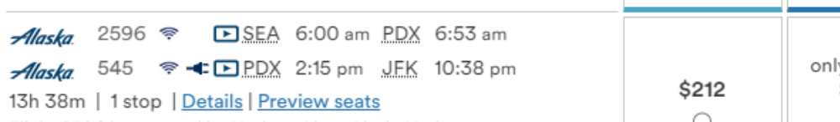
**************************Answer below******************************************
The commonly accepted formula for calculating conversion rate is count of completed transaction divided by total number of site visitors, for a given period. Therefore, presuming a timespan of 1 day, since the table below shows “bucketed prices”, the conversion rate will have to be distributed across individual price points. For example:
Number of compted purchases at $212, divided by Number of site visitors on day x
Number of compted purchases at $264, divided by Number of site visitors on day x
Number of compted purchases at $414, divided by Number of site visitors on day x
However, “overall” conversion rate will be total completed transactions divided by number of site visitors.

2. How does the cost in miles affect the guests’ willingness to purchase? For this question, assume that the conversion space is already tagged successfully, and this data is already accessible.
**************************Answer below******************************************
Since I am not familiar with the term “cost in miles”, I am not able to understand or answer this question.

3. How many times does a guest attempt to search for a destination that we do not serve for the given airport or date? This can be demoed through the following flight search:
This can be calculated by count of Error Code 1580 per UserID, assuming that user session/visit is being tracked while searchng for tickets.

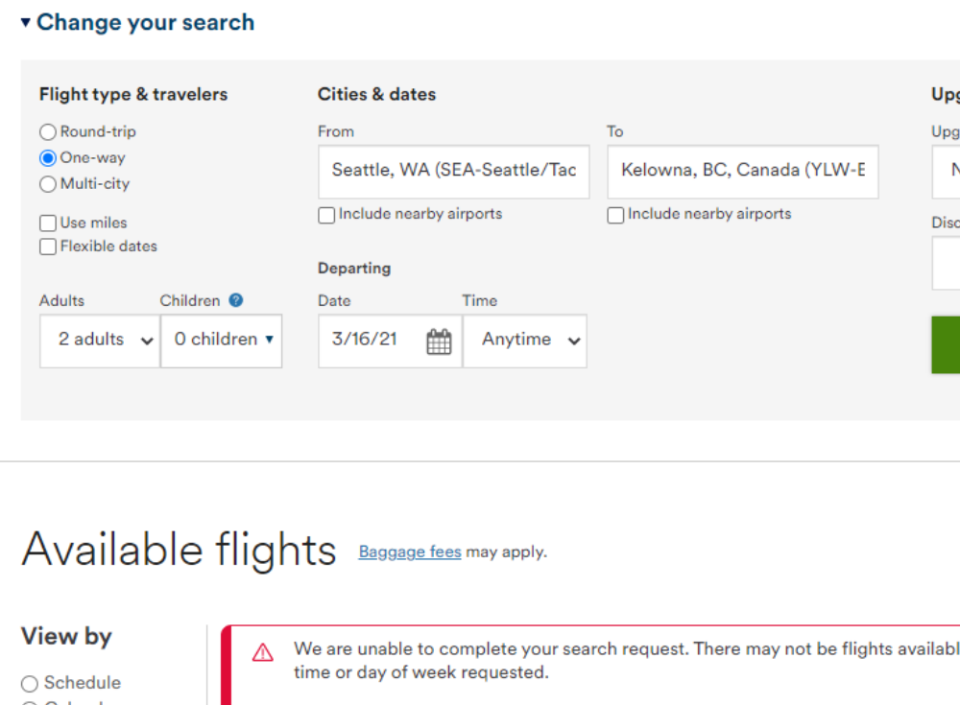

Tasks
- Head over to alaskaair.com and perform a search for any flight. Consider the different elements of data that could be captured through this interaction. We would recommend you at least focus on Flight Search and Flight Results as possible events to model, but feel free to explore beyond those two if you feel further structure is necessary. Modeling these events as a JSON Schema is preferred.
**************************Answer below******************************************
FlIGHT SEARCH DATA
"flightsearch": {
"flighttype” :[
{"flight":"Round-trip"},
{"flight":"One-way"},
{"flight":"Multi-city"},
{"usemiles":0}, assume this will be bit data type?
{"flexdates":1} assume this will be bit data type?
],
"travellers": [
{"adults": 1},
{"children": 0}
],
"upgradetype" : [
{"Upgrade": "Mileage"},
{"Upgrade": "MVP"},
{"Upgrade": "MVP Gold"},
{"Upgrade": "MVP Gold 75"},
{"Upgrade": "MVP Guest"},
{"Upgrade": "MVP"}
],
"schedule": [{"departuredatetime": "2/1/0000:10:00"},
{arrivaldatetime": "2/10/0000:06:00"}
]
};
FlIGHT RESULT DATA
"flightresult": {
[
{"viewby": "Schedule"},
{"viewby": "Calendar"},
{"viewby": "Price"}
],
"resultfilter": [
{"filter": "Non-stop"},
{"filter": "1 stop"},
{"filter": "2+ stops"}
] }
);

2. Describe the tools/process you would use to capture these events as they occur. Feel free to include 3rd party tools as part of this process.
**************************Answer below******************************************
- For marketing analytics in particular, Google Analytics is widely recongnized as one of the tools of choice for setting up data tagging. This can be done in one of two ways:
- Using the provided interface, Google Tag Manager (GTM), one has the option of setting up tagging, either manually or programmatically.
- Using what Google calls “Universal Analytics Enhanced Ecommerce “, one can programmatically capture events data using “custom code” (i.e. java script code) embedded inside HTML code on the web page.
- While Google Analytics is widely used, other vendors such as Piwik have similar services available. In fact, in some sense, Piwik may be a better option. For instance, while GA is only a cloud-based service, Piwik allows for both private cloud, as well as on-premises hosting. More felxible support for data ingestion. For more indepth comparison of the two services, see: Piwik PRO vs. Google Analytics & Google Analytics 360 | Piwik PRO

3. Propose at least two different options of performing this data capture and list each method’s pros and cons. You are welcome to include more than two architectures of tagging if you believe there is reason to do so.
**************************Answer below******************************************
If using Google Analytics, these events can be captured using Google Tag Manager (GTM). There are two ways to accomplish this, using GTM:
- Option 1: Manual Tag Configuration. This will involve using the series of interfaces provided by Google to setup the data elements that one wants to track/tag. Below is an example of what this might involve:
Note: The tags listed below are based on Google Analytics samples, therefore, may not match the file structure shown above. I simply used what was available in Google"s GTM.
(a) CREATE A TAG named "GA4 Air Ticket Transactioins" (use to capture transaction/fact data)
TRANSACTION DATA
VARIABLE to store data for the TAG = “Flight Transactions”
VARIABLE TYPE = “Data Layer Variable”
Data Layer Variable Name = “eCommerce Flight Purchases”
Data Elements/Tags to configure in Data Layer Variable:
TransctID : eCommerce.purchase.actionfield.id
ProductID : eCommerce.purchase.actionfield.productID
ProductType : eCommerce.purchase.actionfield.proucttype (e.g.One-way, return, etc.)
TransactionDate : eCommerce.purchase.actionfield.transasctiondate
DepartureDate : eCommerce.purchase.actionfield.departuredate
ArrivalDate : eCommerce.purchase.actionfield.arrivaldate
DepartureAirport : eCommerce.purchase.actionfield.departureairport
ArrivalAirport : eCommerce.purchase.actionfield.arrivalairport
Price : eCommerce.purchase.actionfield.price
Tax : eCommerce.purchase.actionfield.tax
VisitorCount : eCommerce.purchase.actionfield.visitors (Not surewhat the tag element is called)
CUSTOMER DATA
VARIABLE to store data for the TAG = “Flight Customers”
VARIABLE TYPE = “Data Layer Variable”
Data Layer Variable Name = “eCommerce Flight Customers”
Transct ID : eCommerce.purchase.actionfield.id
Customer/UserID : eCommerce.purchase.actionfield.CustomerID
Customer/MileagePlanNumber : eCommerce.purchase.actionfield.CustomerPlanNumber
Customer Name : eCommerce.purchase.actionfield.CustomerName
CustomerEmail : eCommerce.purchase.actionfield.CustomerEmailAddress

PRODUCT DATA
VARIABLE to store data for the TAG = “Flight Products”
VARIABLE TYPE = “Data Layer Variable”
Data Layer Variable Name = “eCommerce Flight Products”
ProductID : eCommerce.purchase.actionfield.productID
ProductType : eCommerce.purchase.actionfield.proucttype (e.g.One-way, return, etc.)
(b) Create TRIGGER to fire upon purchase event:
Trigger Name = purchase trigger
Trigger Type = custom
Event name = Purchase
Save the trigger
perform a purchase transaction
Check to see if tag has fired, look in tag assistant
Select "Purchase" event; select the TAG--GA4 Flight Transactions
Select "Value" to verify that data has been sent to Google Analytics
Open Debug view to see values

Due to its manual nature, this option is more cumbersome and prone to error.
Option 2: Set up Tagging programmatically, using custom code. Services such as Google Analytics provide sample codes that can be modifed using Java Script to tag events of interest. Sample eCommerce tracking code is avaiable at "Google Developer Resource page".
Using custom code for data tagging is a better option. It is customizable, and less prone to error. It provides for easy code maintenance.
- The capture strategy will pipe directly to a storage strategy. Based on how you chose to model data and how you chose to capture it, please walkthrough the structure the data would have in a database. Please provide at least two methodologies here, listing their pros and cons.
**************************Answer below******************************************
Using data ingestion pipeline (e.g. Azure Data Factory), tagged data can be captured using the providers own API or “custom connector”. If the data sets will be received in json, csv, or parquet format, then the following approaches can be considered.
Options:
(a) Data can be received and ingested using Databricks. Once received, transformation can be carried out within databricks. From there, data can be loaded into data lake or Azure data warehouse.
(b) Receive and land data (json objects) directly into CosmosDB. This option maybe appealing because, CosmosDB is designed to handle semi-structured data such as json files.
(c) While options (a) and (b) are mainly suited for batch processing, it is also possible to ingest data using streaming tools. However, this may not be suitable for this use case.
FOR DETAILS ON ANSWER TO THIS QUESTION, SEE THE FOLLOWING FILES:
Solution.md, AlaskaairDataIngestion.pdf

Process
Create an open source repository in Github to store any information related to your solution. If you would like to give us an overview of how the solution should be read through, please write a Solution.md file to walk us through how we should examine your solution.
You are not required to develop, write pipelines, or create a local database as part of this project, but please be verbose in your explanations. Good communication will be key to success in this role.

Tips
- For any questions that came up in the process of you developing your solution, please write them to a Questions.md file. Additionally, please write out your assumptions as to the answer to the question, so we can capture your logic as you proceeded from having said question.
- Your success will be measured against your ability to:
- Create a durable model definition that will ultimately lead to strong data storage structures that can answer the questions presented in the Objective.
- Create a durable model definition that accurately represents the customer interaction and provides a pathway to answer further questions beyond those listed in the Objective.
- Explain multiple points of view for possible strategies, positioning pros against cons for a final decision.
- Write well suited documentation around your ideas so that it can be clearly understood when we review before the actual interview.
Please send an email to david.sink@alaskaair.com; Joshua.Benard@alaskaair.com; karunya.namuduri@alaskaair.com; daidre.gothard@alaskaair.com with a link to your repository when you have completed the exercise.

